For Immediate Release

SD FFA Highlights Agriculture with Ag Adventure Zone
SD FFA is highlighting agriculture in the Rodeo Zone during Rodeo Rapid City, Jan. 28-Feb. 5, 2022. The Ag Adventure Zone is sponsored by South Dakota Farm Bureau as a special project of the SD FFA Foundation.
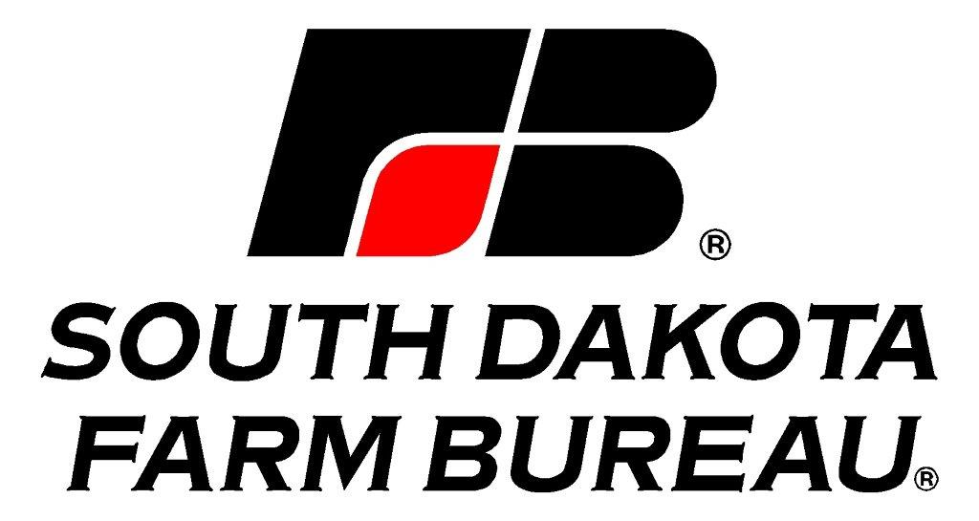
Located in the Ice Arena at The Monument, in Rapid City, the Ag Adventure Zone will illustrate the diversity of South Dakota agriculture, with interactive and educational exhibits on beef, swine, grain, and more from production to processing. The Ag Adventure Zone’s mission is to: showcases modern agricultural practices, communicates commitment to natural resources and demonstrates wholesome, safe food production for all ages. Industry volunteers, State FFA officers and District 5 FFA members will be at the Ag Adventure Zone to host activities and interact with BHSS attendees.

“We are extremely thankful for the support of the South Dakota Farm Bureau and Sutton Rodeo to bring this important event to Rodeo Rapid City. We hope that this partnership will carry on for years to come so we can continue to educate the public about agriculture,” says South Dakota FFA Executive Secretary Dani Herring.

The SD FFA is also launching “FFA Day” on Monday, January 31st as part of Rodeo Rapid City. High school FFA members from South Dakota, Nebraska, and Wyoming will attend interactive presentations, learning from industry leaders on topics in four agriculture pathways: animal systems, plant systems, power/structural systems and advocacy/ communications. Presenters include: SD Farm Bureau, SD Pork Producers, SD Beef Industry Council, SD Stock Growers, Tyson Foods, SD Soil Health Coalition, Dakota Grain Mill, BASF, Butler Machinery, Agtegra, Brink Construction, and the SD National Guard. FFA members will gain insight into current agricultural practices and innovations and ask the experts questions. Members will also attend a livestock judging school, cattle shows and sales, and visit vendors.
###

